import locale

def get_income():

while True:

try:

income = input("Please enter your monthly income: $")

income = float(income)

if income < 0:

print("Income cannot be negative. Please try again.")

else:

return income

except ValueError:

print("Invalid input! Please enter a valid number for your income.")

def get_expenses():

expenses = []

while True:

try:

expense_input = input("Enter an expense (or type 'done' to finish): $")

if expense_input.lower() == 'done':

break

expense = float(expense_input)

if expense < 0:

print("Expense cannot be negative. Please try again.")

else:

expenses.append(expense)

except ValueError:

print("Invalid input! Please enter a valid number for your expense.")

return expenses

def calculate_budget(income, expenses):

total_expenses = sum(expenses)

remaining_budget = income - total_expenses

return total_expenses, remaining_budget

def main():

locale.setlocale(locale.LC_ALL, 'en_US.UTF-8')

print("Welcome to the Budget Tracker program. This program will help you manage your monthly income and expenses.")

income = get_income()

expenses = get_expenses()

total_expenses, remaining_budget = calculate_budget(income, expenses)

print("\n--- Budget Summary ---")

print(f"Total Income: {locale.currency(income, grouping=True)}")

print(f"Total Expenses: {locale.currency(total_expenses, grouping=True)}")

print(f"Remaining Budget: {locale.currency(remaining_budget, grouping=True)}")

print("\n--- List of Expenses ---")

for i, expense in enumerate(expenses, 1):

print(f"Expense {i}: {locale.currency(expense, grouping=True)}")

print("Completed by Ben Andrews")

if __name__ == "__main__":

main()

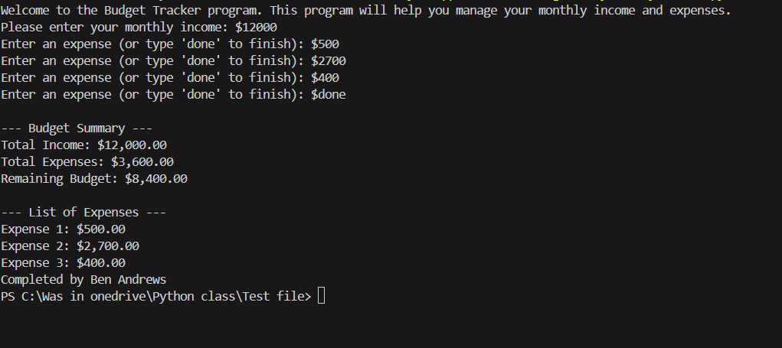For some reason this one was fun to see come together as I was testing.